DATEROEM WOOD SALES
System Documentation
Mobile Server (BFF)
The FastAPI service behind the staff mobile app
Document | Mobile Server (BFF)
Document number | DWS-MOB-01
Version | 1.1
Date | 26 October 2026
Intended readers | Developers and maintainers of the system
Classification | Internal - contains system design details; share only with authorised staff
Describes the mobile server in mobileServer/: how phones reach it, what it adds on top of the backend (uploads, media, trip batching), every route, its settings and how to run it.

Document control
Version | Date | Change
1.0 | 3 October 2026 | First complete edition, written from the source code as it stood on this date.
1.1 | 3 October 2026 | Added one approved phone per account (admin approval of new phones) and the fingerprint app lock.
1.1 | 4 October 2026 | Routes to read and replace the products a campaign promotes; note on media keys.
1.1 | 9 October 2026 | Routes to retire and bring back a product and list out-of-stock products; product lists include retired products; API description pages off; customer accounts refused at sign-in.
1.1 | 9 October 2026 | Bulk Orders page pictures: /showcase routes and the /uploads/showcase upload (Marketer, Admin or SuperAdmin).
1.1 | 18 October 2026 | Calm error answers (backend_client.py and main.py), as on the website server.
1.1 | 20 October 2026 | Route to save the account's colour theme from the phone app's Settings (PUT /auth/me/theme).
1.1 | 23 October 2026 | Route for Share driver on a light delivery from the phone app (PATCH /deliveries/light/{id}/share-driver); assignments and new light deliveries carry shareDriver.
1.1 | 24 October 2026 | Routes for the profile: PUT /auth/me/profile, POST /auth/me/password, POST and DELETE /auth/me/photo (the photo from the camera or gallery, turned upright, cut to a centred 512 px square here and saved in media/profiles).
1.1 | 24 October 2026 | Routes for Home: GET /insights/overview (Admins and the SuperAdmin) and GET and PUT /settings/company (the SuperAdmin changes the card).
1.1 | 24 October 2026 | Routes for Worker details: GET and PUT /workers/me, and POST /workers/me/documents/{type_key} - the photo from the camera or gallery is turned upright and shrunk to at most 1600 px here, then sent on for the backend to encrypt.
1.1 | 24 October 2026 | Named: app/core/profile_photos.py saves a profile photo (squared, at most 1 MB) as media/profiles/u<id>-<random>.jpg and deletes the old one. Here it also turns the phone's photo upright.
1.1 | 26 October 2026 | Campaign retire routes (POST /marketing/campaigns/{campaign_id}/retire and /unretire); GET /marketing/campaigns passes includeRetired on only when the app asks.
Keep this document up to date: when a feature, setting or server changes, edit the matching section here and add a line to the table above.
Contents
1 Introduction 4
2 What it adds on top of the backend 6
2.1 Photo and video uploads 6
2.2 Media serving and URL rewriting 7
2.3 Passing on the sign-in token 7
2.4 Trip list sized to load 8
2.5 Other behaviour 8
3 Routes 9
3.1 ai_chat.py 9
3.2 auth.py 9
3.3 bulk_orders.py 9
3.4 deliveries.py 10
3.5 expenses.py 10
3.6 finance.py 10
3.7 health.py 11
3.8 insights.py 11
3.9 settings.py 11
3.10 machines_vehicles.py 11
3.11 marketing.py 12
3.12 orders.py 12
3.13 products.py 12
3.14 shipping.py 13
3.15 showcase.py 13
3.16 sms_queue.py 13
3.17 transactions.py 14
3.18 trees.py 14
3.19 trips.py 15
3.20 uploads.py 15
3.21 users.py 16
3.22 workers.py 16
4 Configuration 17
5 Running and checking 18

1 Introduction
The mobile server is the only server the staff Android app talks to. It forwards each request to the Java backend together with the phone's sign-in token, saves uploaded photos and videos into the shared media folder, and serves those files back to the phone.
Item | Detail
Location | /root/fathersProject/mobileServer (virtual environment in mobileServer/venv)
Framework | FastAPI on uvicorn, httpx, pydantic-settings, Pillow (image resizing), python-multipart (uploads)
Port | 8001 (all addresses)
Reached by | USB test phone: http://127.0.0.1:8001/ through adb reverse tcp:8001 tcp:8001; shared APK: https://<public domain>/mobile-api/ through ngrok and Caddy
Calls | The backend at BACKEND_BASE_URL (http://localhost:8080)
Start command | cd /root/fathersProject/mobileServer && venv/bin/uvicorn app.main:app --host 0.0.0.0 --port 8001 --reload

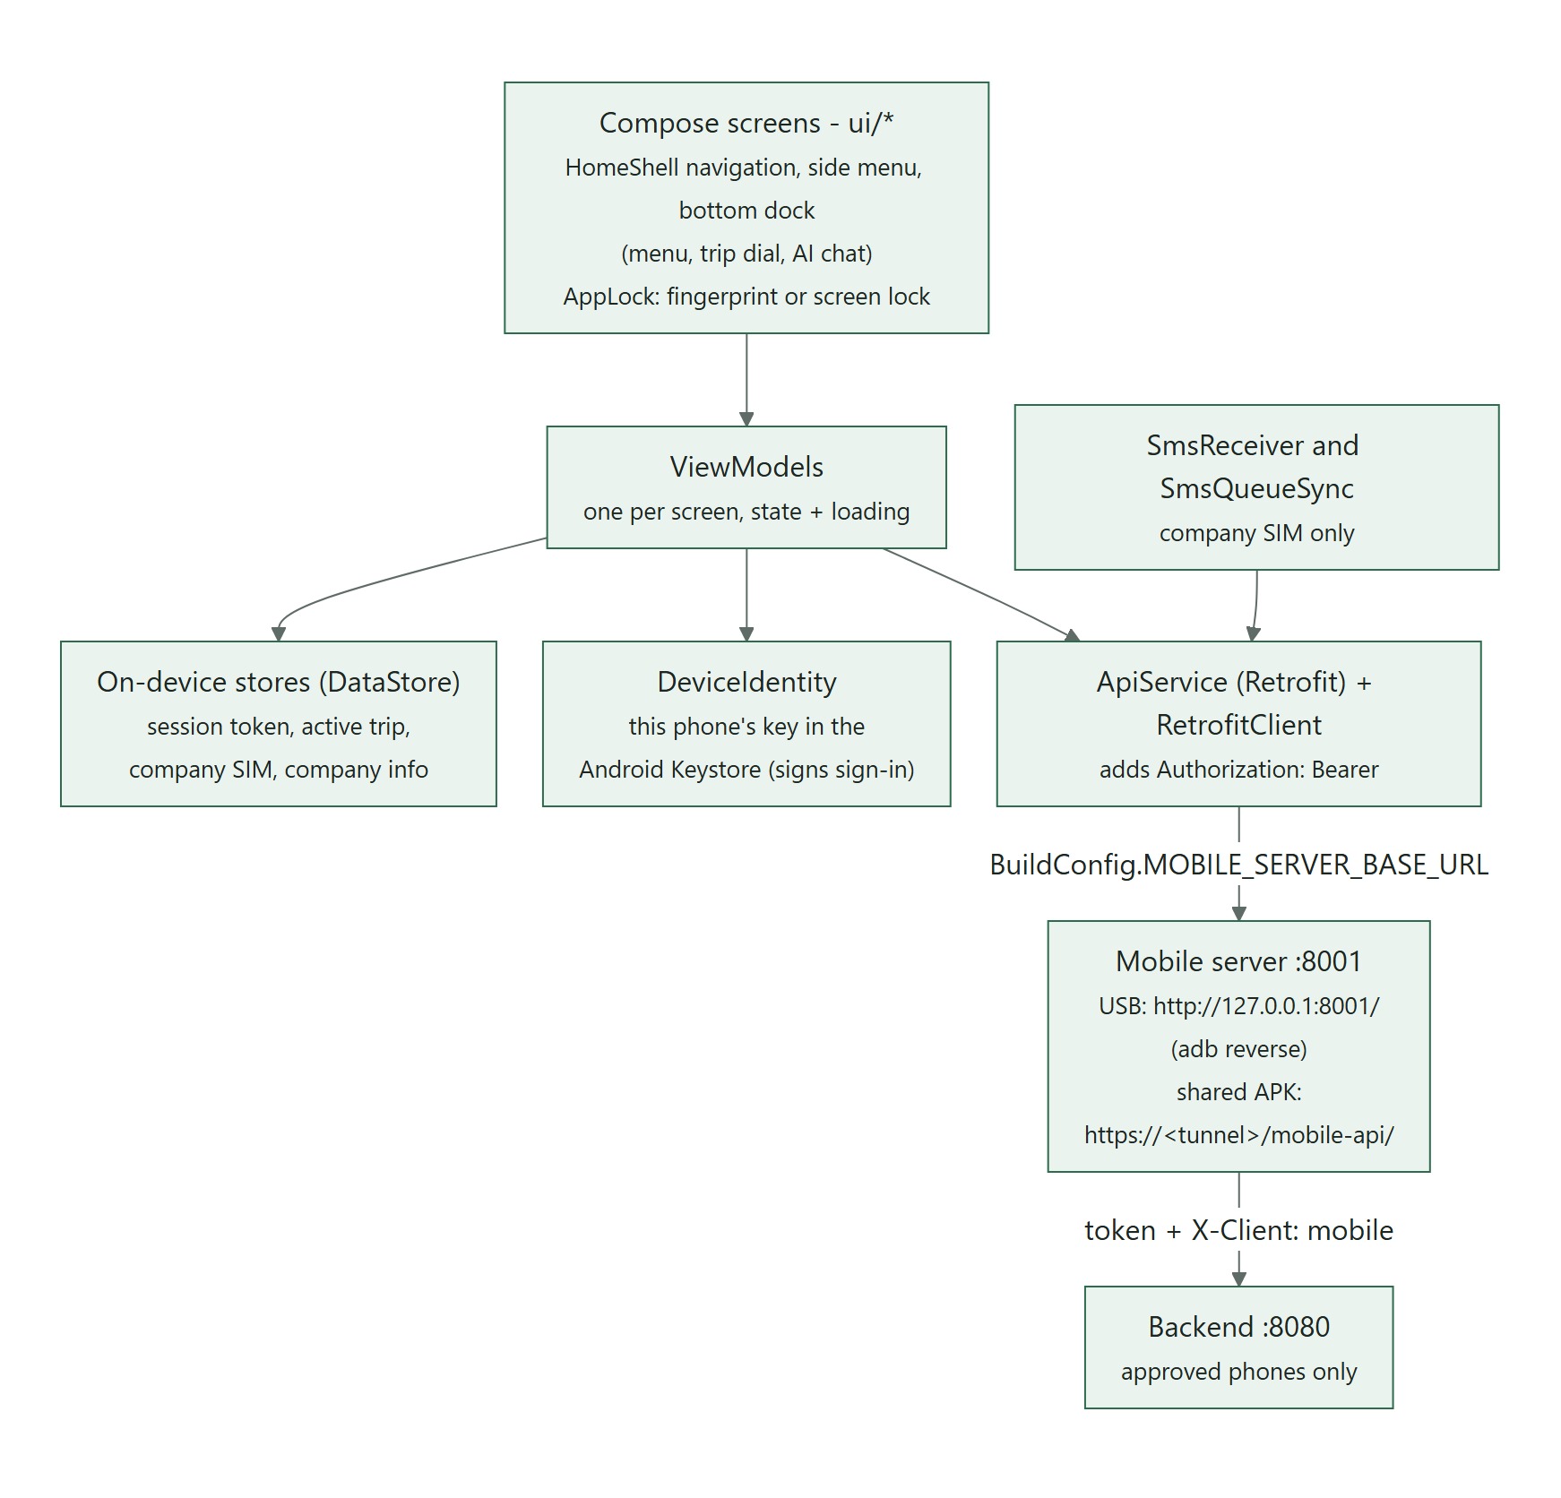
Figure 1: The mobile app, the mobile server and the backend

2 What it adds on top of the backend

2.1 Photo and video uploads
routers/uploads.py receives files from the phone and writes them into the shared media folder, so the website and the desktop see them immediately.
Upload | Rules
POST /uploads/products?name=<product name> | Image up to 15 MB; resized to at most 1600 px and saved as JPEG (quality 85) in media/products, named after the product plus a short random suffix
POST /uploads/campaigns?name=<campaign name> | Image (same rules, media/campaigns) or video up to 60 MB (mp4, mov, webm, 3gp, m4v), saved unchanged
POST /uploads/showcase?name=<caption> | Bulk Orders page picture (since 9 October 2026): image, same rules as a product photo, saved in media/showcase; Marketer, Admin or SuperAdmin only

The response is the relative key (for example products/rose-wood-1a2b3c4d.jpg), which the app then saves on the product or campaign.
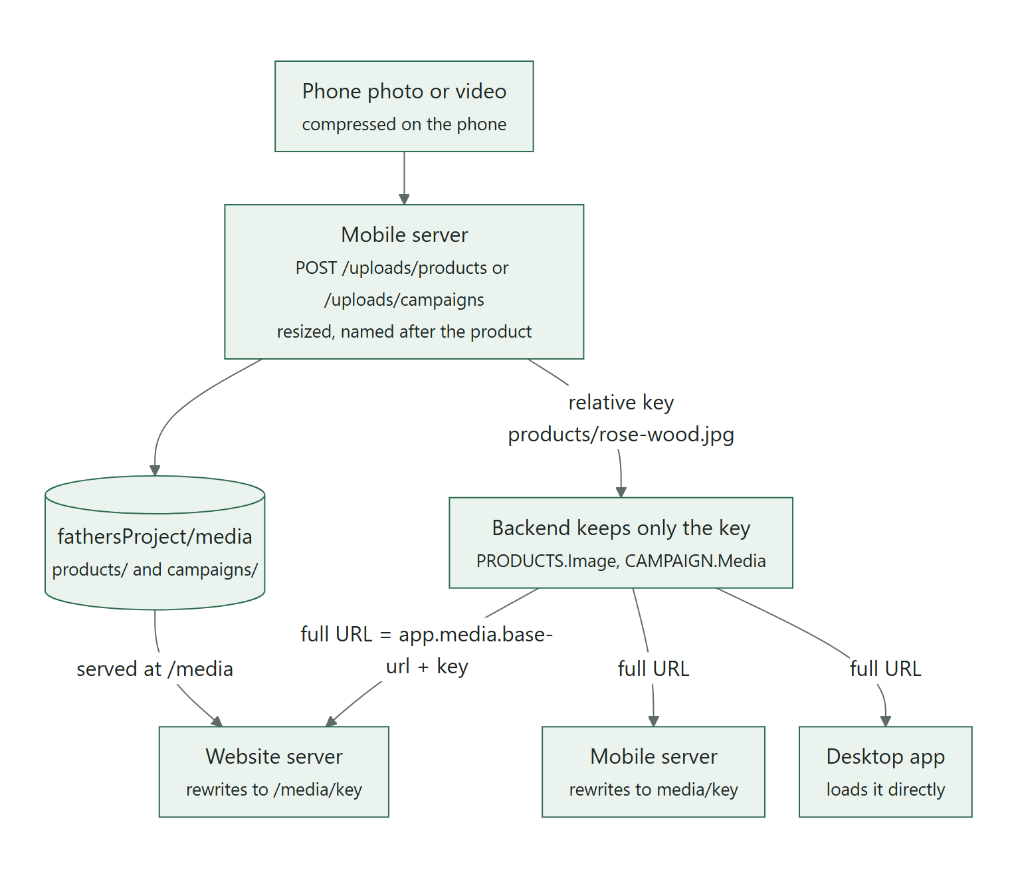
Figure 2: How a photo travels from the phone to every client

2.2 Media serving and URL rewriting
The server mounts the media folder at /media. Image URLs from the backend (http://127.0.0.1:8000/media/...) only work on the company computer, so core/backend_client.py rewrites them to media/..., which the app resolves against its own base address - USB, LAN or tunnel alike.
Note: Because of this rewriting, a campaign or product the phone loads carries media/campaigns/..., not the stored key. The app turns it back into the bare key (mediaKeyOf in CampaignFormViewModel.kt) before saving, and the backend does the same (MediaUrls.toKey), so editing never drops an existing photo or video.

2.3 Passing on the sign-in token
Since 3 October 2026 only approved phones may use this server (see the Backend Server document, Approved phones). The server itself makes no approval decision; it makes sure the backend can:
- app/main.py has a small middleware, remember_authorization, that keeps the Authorization header of each incoming request in a context variable (app/core/request_context.py).
- Every call in app/core/backend_client.py adds that header and X-Client: mobile. The backend sees the mark, checks that the token names an approved phone and takes the acting user from the token.
- Sign-in has an extra step: GET /auth/device/challenge returns the one-time value the phone signs, and POST /auth/login forwards the signed proof (device) with the username and password.
- The upload routes write files on this server without calling the backend, so they first call /api/auth/me (_require_approved_phone in routers/uploads.py). A phone that is not approved cannot upload. The showcase upload also checks the role that answer gives (SHOWCASE_EDITORS: Marketer, Admin, SuperAdmin), so no one else can leave files in media/showcase.

Where to adjust: If a new route calls the backend, use the shared backend_client functions so the token and the X-Client mark are added automatically. A route that only touches this server (like uploads) must call _require_approved_phone() or an equivalent check first.

2.4 Trip list sized to load
Following the business rule "send only 3-6 trips, fewer at busy times", /trips asks the backend for 6 trips when it is quiet, 4 with 2-3 requests in progress, 2 with up to 6, and 1 above that.

2.5 Other behaviour
- Gzip compression for JSON responses over 500 bytes.
- Errors (since 18 October 2026): app/core/backend_client.py never passes on technical details. A backend that can't be reached becomes 503 "We can't reach our server right now ...", a slow one 504, and any backend 500 becomes "Something went wrong on our side ..." - the real error goes to this server's log. A reason the backend wrote for people (any 4xx, or a deliberate 503 such as "Text messages are not set up yet.") passes through; a 4xx without one gets a plain sentence for its status. app/main.py answers a request with fields that don't fit with one sentence (422) and anything unexpected with the calm 500, logging the trace.
- Longer time-outs for AI chat and the handwriting scan (up to 45 seconds).
- Campaign products: GET /marketing/campaigns/{campaign_id}/products reads and PUT (body {"productIds": [...]}) replaces the products a campaign promotes, for the picker on the app's campaign form.
- Retiring a campaign (26 October 2026): POST /marketing/campaigns/{campaign_id}/retire and /unretire with the acting user. GET /marketing/campaigns?includeRetired=true (the app's Marketing list) includes retired campaigns, marked isRetired; without it (Home, and app copies from before) they are left out, so an older app never shows a retired campaign as running.
- Endpoints that change data still take an X-Actor-User-Id header from the app and pass it on, but the backend replaces it with the user in the verified token, so a wrong or altered value has no effect.

Security: This server is reachable from the internet through the tunnel. Every request it passes on is checked by the backend for a token issued to an approved phone, and the acting user is taken from that token (closed on 3 October 2026; previously the id from the phone was trusted). Keep the X-Client: mobile mark on every backend call: without it the backend treats the call as coming from the company computer.

3 Routes
Paths as seen by this server; through the tunnel they are prefixed with /mobile-api. "Passes" shows what identity is forwarded to the backend.
Note: Since 9 October 2026: product lists and single products include retired ones (includeRetired=true, marked isRetired); GET /products/depleted and POST /products/{id}/retire and /unretire serve the app's retire feature; the API description pages are off; and the backend refuses customer accounts at sign-in.

3.1 ai_chat.py
Method | Path | Handler | Backend call | Passes
POST | /ai/chat | Send message | POST /api/ai/chat | acting user id
GET | /ai/chat/history | History | GET /api/ai/chat/history | acting user id

3.2 auth.py
Method | Path | Handler | Backend call | Passes
GET | /auth/device/challenge | Device challenge | GET /api/auth/device/challenge | token
POST | /auth/login | Login | POST /api/auth/login | token
GET | /auth/me | Me | GET /api/auth/me | token
PUT | /auth/me/theme | Save theme | PUT /api/auth/me/theme | token
PUT | /auth/me/profile | Update profile | PUT /api/auth/me/profile | token
POST | /auth/me/password | Change password | POST /api/auth/me/password | token
POST | /auth/me/photo | Upload photo | PUT /api/auth/me/photo | token
DELETE | /auth/me/photo | Remove photo | PUT /api/auth/me/photo | token

3.3 bulk_orders.py
Method | Path | Handler | Backend call | Passes
GET | /bulk-orders | List bulk orders | GET /api/deliveries/bulk
GET | /bulk-orders/{bulk_delivery_id} | Get bulk order | GET /api/deliveries/bulk/{bulk_delivery_id}
GET | /bulk-orders/{bulk_delivery_id}/production | Bulk order production | GET /api/deliveries/bulk/{bulk_delivery_id}/production
POST | /bulk-orders | Create bulk order | POST /api/deliveries/bulk | acting user id
DELETE | /bulk-orders/{bulk_delivery_id} | Delete bulk order | DELETE /api/deliveries/bulk/{bulk_delivery_id} | acting user id
PATCH | /bulk-orders/{bulk_delivery_id}/finalize | Finalize bulk order | PATCH /api/deliveries/bulk/{bulk_delivery_id}/finalize | acting user id

3.4 deliveries.py
Method | Path | Handler | Backend call | Passes
GET | /deliveries/light | List light deliveries | GET /api/deliveries/light
PATCH | /deliveries/light/{light_delivery_id}/status | Update light delivery status | PATCH /api/deliveries/light/{light_delivery_id}/status
PATCH | /deliveries/light/{light_delivery_id}/deliver | Deliver light delivery | PATCH /api/deliveries/light/{light_delivery_id}/deliver
PATCH | /deliveries/light/{light_delivery_id}/share-driver | Share driver | PATCH /api/deliveries/light/{light_delivery_id}/share-driver | acting user id
GET | /deliveries/light/pending-groups | Pending order groups | GET /api/deliveries/light/pending-groups
POST | /deliveries/light/assign-batch | Assign batch | POST /api/deliveries/light/assign-batch | acting user id
POST | /deliveries/light/settle | Settle light orders | POST /api/deliveries/light/settle | acting user id
POST | /deliveries/light | Create light delivery | POST /api/deliveries/light | acting user id

3.5 expenses.py
Method | Path | Handler | Backend call | Passes
GET | /trips/{trip_id}/expenses | Category totals | GET /api/trips/{trip_id}/expenses
GET | /trips/{trip_id}/expenses/{category} | Line items | GET /api/trips/{trip_id}/expenses/{category}
POST | /trips/{trip_id}/expenses/{category} | Create expense | POST /api/trips/{trip_id}/expenses/{category} | acting user id
DELETE | /trips/{trip_id}/expenses/{category}/{row_id} | Delete expense | DELETE /api/trips/{trip_id}/expenses/{category}/{row_id} | acting user id

3.6 finance.py
Method | Path | Handler | Backend call | Passes
GET | /trips/{trip_id}/finance/loans | Loans | GET /api/trips/{trip_id}/finance/loans
POST | /trips/{trip_id}/finance/loans | Create loan | POST /api/trips/{trip_id}/finance/loans | acting user id
PATCH | /loans/{loan_id} | Update loan | PATCH /api/loans/{loan_id} | acting user id
GET | /trips/{trip_id}/finance/capital | Capital | GET /api/trips/{trip_id}/finance/capital
GET | /loans/{loan_id}/repayments | Repayments | GET /api/loans/{loan_id}/repayments
POST | /loans/{loan_id}/repayments | Record repayment | POST /api/loans/{loan_id}/repayments
POST | /loans/{loan_id}/repayments/pay | Pay loan | POST /api/loans/{loan_id}/repayments/pay | acting user id

3.7 health.py
Method | Path | Handler | Backend call | Passes
GET | /health | Health | - (handled here)

3.8 insights.py
Method | Path | Handler | Backend call | Passes
GET | /insights/expenses/breakdown | Expense breakdown | GET /api/insights/expenses/breakdown
GET | /insights/overview | Overview | GET /api/insights/overview

3.9 settings.py
Method | Path | Handler | Backend call | Passes
GET | /settings/company | Company | GET /api/settings/company | token
PUT | /settings/company | Set company | PUT /api/settings/company | token

3.10 machines_vehicles.py
Method | Path | Handler | Backend call | Passes
GET | /machines | List machines | GET /api/machines
GET | /vehicles | List vehicles | GET /api/vehicles

3.11 marketing.py
Method | Path | Handler | Backend call | Passes
GET | /marketing/campaigns | List campaigns | GET /api/marketing/campaigns
GET | /marketing/campaigns/deleted | List deleted campaigns | GET /api/marketing/campaigns/deleted
GET | /marketing/campaigns/{campaign_id} | Get campaign | GET /api/marketing/campaigns/{campaign_id}
POST | /marketing/campaigns | Create campaign | POST /api/marketing/campaigns | acting user id
PATCH | /marketing/campaigns/{campaign_id} | Update campaign | PATCH /api/marketing/campaigns/{campaign_id} | acting user id
DELETE | /marketing/campaigns/{campaign_id} | Delete campaign | DELETE /api/marketing/campaigns/{campaign_id} | acting user id
POST | /marketing/campaigns/{campaign_id}/restore | Restore campaign | POST /api/marketing/campaigns/{campaign_id}/restore | acting user id
POST | /marketing/campaigns/{campaign_id}/retire | Retire campaign | POST /api/marketing/campaigns/{campaign_id}/retire | acting user id
POST | /marketing/campaigns/{campaign_id}/unretire | Unretire campaign | POST /api/marketing/campaigns/{campaign_id}/unretire | acting user id
POST | /marketing/campaigns/{campaign_id}/products/{product_id} | Link product | POST /api/marketing/campaigns/{campaign_id}/products/{product_id}
GET | /marketing/campaigns/{campaign_id}/products | Campaign products | GET /api/marketing/campaigns/{campaign_id}/products
PUT | /marketing/campaigns/{campaign_id}/products | Set campaign products | PUT /api/marketing/campaigns/{campaign_id}/products | acting user id

3.12 orders.py
Method | Path | Handler | Backend call | Passes
POST | /orders/{order_id}/drop | Drop order | POST /api/orders/{order_id}/drop | token
GET | /orders/refunds/pending | Pending refunds | GET /api/orders/refunds/pending | token

3.13 products.py
Method | Path | Handler | Backend call | Passes
GET | /products | List products | GET /api/products
GET | /products/deleted | List deleted products | GET /api/products/deleted
GET | /products/depleted | List depleted products | GET /api/products/depleted
GET | /products/{product_id} | Get product | GET /api/products/{product_id}
POST | /products | Create product | POST /api/products | acting user id
PATCH | /products/{product_id} | Update product | PATCH /api/products/{product_id} | acting user id
DELETE | /products/{product_id} | Delete product | DELETE /api/products/{product_id} | acting user id
POST | /products/{product_id}/restore | Restore product | POST /api/products/{product_id}/restore | acting user id
POST | /products/{product_id}/retire | Retire product | POST /api/products/{product_id}/retire | acting user id
POST | /products/{product_id}/unretire | Unretire product | POST /api/products/{product_id}/unretire | acting user id

3.14 shipping.py
Method | Path | Handler | Backend call | Passes
GET | /shipping/areas | List areas | GET /api/shipping/areas
GET | /shipping/areas/{area_id} | Get area | GET /api/shipping/areas/{area_id}
POST | /shipping/areas | Create area | POST /api/shipping/areas
PATCH | /shipping/areas/{area_id} | Update area | PATCH /api/shipping/areas/{area_id}

3.15 showcase.py
Method | Path | Handler | Backend call | Passes
GET | /showcase | List pictures | GET /api/showcase
POST | /showcase | Add picture | POST /api/showcase
PUT | /showcase/order | Reorder pictures | PUT /api/showcase/order
PATCH | /showcase/{showcase_id} | Edit caption | PATCH /api/showcase/{showcase_id}
DELETE | /showcase/{showcase_id} | Remove picture | DELETE /api/showcase/{showcase_id}

3.16 sms_queue.py
Method | Path | Handler | Backend call | Passes
POST | /sms-queue | Ingest sms | POST /api/sms-queue | token

3.17 transactions.py
Method | Path | Handler | Backend call | Passes
GET | /transactions/unassigned | Unassigned | GET /api/transactions/unassigned
POST | /transactions/claim | Claim | POST /api/transactions/claim | acting user id
GET | /transactions/claimed | Claimed | GET /api/transactions/claimed | acting user id
POST | /transactions/{financial_transaction_id}/release | Release | POST /api/transactions/{financial_transaction_id}/release
GET | /transactions/{financial_transaction_id}/candidates | Candidates | GET /api/transactions/{financial_transaction_id}/candidates
POST | /transactions/{financial_transaction_id}/assign | Assign | POST /api/transactions/{financial_transaction_id}/assign | acting user id
POST | /transactions/farmer-payments | Send to farmer | POST /api/farmer-payments | acting user id
POST | /transactions/stk-push | Stk push | POST /api/transactions/stk-push | acting user id
POST | /transactions/{financial_transaction_id}/stk-push/confirm | Confirm stk push | POST /api/transactions/{financial_transaction_id}/stk-push/confirm | acting user id
POST | /transactions/send-money | Send money | POST /api/transactions/send-money | acting user id
GET | /transactions/send-money/recipient | Send money recipient | GET /api/transactions/send-money/recipient
GET | /transactions/{financial_transaction_id}/status | Payment status | GET /api/transactions/{financial_transaction_id}/status
POST | /transactions/{financial_transaction_id}/send-money/confirm | Confirm send money | POST /api/transactions/{financial_transaction_id}/send-money/confirm | acting user id

3.18 trees.py
Method | Path | Handler | Backend call | Passes
GET | /farmers | List farmers | GET /api/farmers
POST | /farmers | Create farmer | POST /api/farmers
PATCH | /farmers/{farmer_id} | Update farmer | PATCH /api/farmers/{farmer_id}
GET | /farmers/insights/top-suppliers | Farmer top suppliers | GET /api/farmers/insights/top-suppliers
GET | /remainder-trees | List remainder trees | GET /api/remainder-trees
POST | /remainder-trees | Create remainder tree | POST /api/remainder-trees
PATCH | /remainder-trees/{remainder_trees_id} | Update remainder tree | PATCH /api/remainder-trees/{remainder_trees_id}
GET | /trees | List trees | GET /api/trees
POST | /trees | Create tree | POST /api/trees
PATCH | /trees/{trees_id} | Update tree | PATCH /api/trees/{trees_id}
GET | /trees/deleted | List deleted trees | GET /api/trees/deleted
DELETE | /trees/{trees_id} | Delete tree | DELETE /api/trees/{trees_id} | acting user id
POST | /trees/{trees_id}/restore | Restore tree | POST /api/trees/{trees_id}/restore | acting user id

3.19 trips.py
Method | Path | Handler | Backend call | Passes
GET | /trips | List trips | GET /api/trips
GET | /trips/open | Open trip | GET /api/trips/open
GET | /trips/{trip_id}/finalization | Finalization check | GET /api/trips/{trip_id}/finalization
POST | /trips/{trip_id}/finalize | Finalize trip | POST /api/trips/{trip_id}/finalize | acting user id
GET | /trips/{trip_id} | Get trip | GET /api/trips/{trip_id}
GET | /trips/{trip_id}/summary | Trip summary | GET /api/trips/{trip_id}/summary
GET | /trips/{trip_id}/deliveries | Trip deliveries | GET /api/deliveries/light; GET /api/deliveries/bulk
POST | /trips | Create trip | POST /api/trips | acting user id
PATCH | /trips/{trip_id} | Update trip | PATCH /api/trips/{trip_id}
POST | /trips/{trip_id}/total-payment/recalculate | Recalculate total payment | POST /api/trips/{trip_id}/total-payment/recalculate
PUT | /trips/{trip_id}/cash-split | Set cash split | PUT /api/trips/{trip_id}/cash-split

3.20 uploads.py
Method | Path | Handler | Backend call | Passes
POST | /uploads/products | Upload product image | auth | token
POST | /uploads/showcase | Upload showcase picture | GET /api/auth/me | token
POST | /uploads/campaigns | Upload campaign media | auth | token

3.21 users.py
Method | Path | Handler | Backend call | Passes
GET | /users/lookup-by-phone | Lookup by phone | GET /api/users/lookup-by-phone | token
GET | /users/picker | List for picker | GET /api/users/picker | token

3.22 workers.py
Method | Path | Handler | Backend call | Passes
GET | /workers/me | My details | GET /api/workers/me | token
PUT | /workers/me | Save my details | PUT /api/workers/me | token
POST | /workers/me/documents/{type_key} | Upload my document | POST /api/workers/me/documents/{type_key} | token

4 Configuration
Setting (mobileServer/.env) | Value today | Purpose
BACKEND_BASE_URL | http://localhost:8080 | Where the backend is
MEDIA_BASE_URL | http://127.0.0.1:8000/media/ | Must equal the backend's app.media.base-url so image URLs can be rewritten
DB_HOST, DB_PORT, DB_NAME, DB_USER, DB_PASSWORD | localhost, 3309, dateroem, dateroem_mobile | Reserved - not used
REDIS_URL | redis://localhost:6379/1 | Reserved for a future cache - not used

5 Running and checking
cd /root/fathersProject/mobileServer
venv/bin/uvicorn app.main:app --host 0.0.0.0 --port 8001 --reload

curl http://127.0.0.1:8001/health
# Phone on USB (from Windows):
adb reverse tcp:8001 tcp:8001
The desktop Servers section starts this server ("Mobile Server BFF") and re-applies adb reverse automatically when a phone is connected, because the rule is lost after a reboot or a USB re-plug.

